**Program:1**

**package** Practice3;

**import** java.util.Scanner;

**abstract** **class** Shape1{

**abstract** **void** numberofsides();

**protected** **double** area;

**public** **double** getArea() {

**return** area;

}

**protected** **abstract** **void** onAreaChange();

}

**class** Triangle1 **extends** Shape1 {

**void** numberofsides() {

System.***out***.println("Number of sides of Triangle is : 3");

}

@Override

**protected** **void** onAreaChange() {

}}

**class** Trepizoid1 **extends** Shape1 {

@Override

**protected** **void** onAreaChange() {

}

**void** numberofsides() {

System.***out***.println("Number of sides of Trapeziod is : 4");

}

}

**class** Hexgon1 **extends** Shape1 {

**protected** **void** onAreaChange() {

}

@Override

**void** numberofsides() {

System.***out***.println("Number of sides of Hexagon is : 6");

}

}

**public** **class** Main1 {

**public** **static** Scanner *scan* = **new** Scanner(System.***in***);

**public** **static** **void** main(String[] args) {

Shape1 s;

**double** base;

**double** height;

**double** side1, side2, height1;

{

System.***out***.println("Enter the number which you want to compute the area");

System.***out***.print("(1) Triangle (2) Trepizoid (3) Hexgon ? ");

**switch** (*scan*.nextInt()) {

**case** 1:

s=**new** Triangle1();

s.numberofsides();

Triangle1 triangle = **new** Triangle1();

System.***out***.print("Base: ");

base=*scan*.nextDouble();

System.***out***.print("Height: ");

height=*scan*.nextDouble();

**double** area = 0.5 *base * height;

System.***out***.println("Area of triangle: " +area);

**break**;

**case** 2:

s=**new** Trepizoid1();

s.numberofsides();

Trepizoid1 trepizoid=**new** Trepizoid1();

System.***out***.println("Enter Length of Two Parallel Sides of Trapezium");

side1=*scan*.nextDouble();

side2=*scan*.nextDouble();

System.***out***.println("Enter Height of Trapezium");

height1=*scan*.nextDouble();

area = 1.0 / 2 * (side1 + side2) * height1;

System.***out***.println("Area of trepizoid " + area);

**break**;

**case** 3:

s=**new** Hexgon1();

s.numberofsides();

Hexgon1 hexgon=**new** Hexgon1();

System.***out***.println("Enter the side of a hexagon");

**double** side=*scan*.nextDouble();

area = ((3 * Math.*sqrt*(3) * (side * side)) / 2); ;

System.***out***.println("Area of hexhon " + area);

**break**;

}

}

}

}

**Output:**

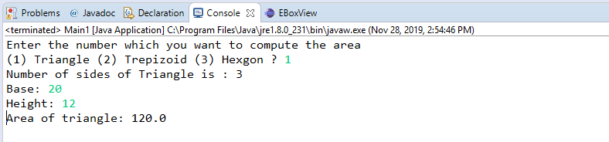

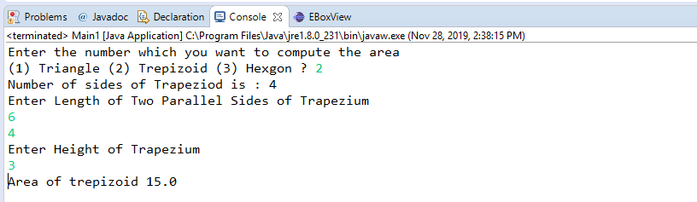

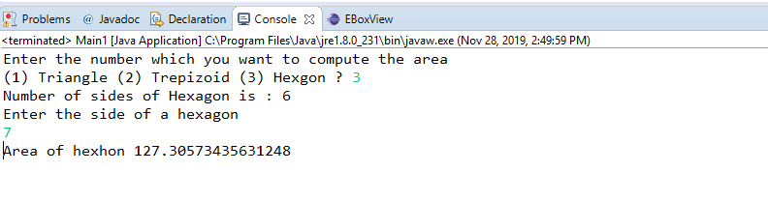

**Program:2**

**import** java.io.IOException;

**import** java.util.ArrayList;

**import** java.util.List;

**import** java.util.Scanner;

**class** Connection {

**private** String databaseUrl;

**private** String userName;

**private** String passWord;

**public** String getDatabaseUrl() {

**return** databaseUrl;

}

**public** **void** setDatabaseUrl(String databaseUrl) {

**this**.databaseUrl = databaseUrl;

}

**public** String getUserName() {

**return** userName;

}

**public** **void** setUserName(String userName) {

**this**.userName = userName;

}

**public** String getPassWord() {

**return** passWord;

}

**public** **void** setPassWord(String passWord) {

**this**.passWord = passWord;

}}

**public** **class** Connectiongc {

**public** **static** **void** main(String[] args) **throws** IOException {

**boolean** flag = **true**;

**char** reply = 'y';

**int** connectionCounter = 0;

Scanner sc = **new** Scanner(System.***in***);

List<Connection> conList = **new** ArrayList();

**while** (flag) {

System.***out***.print("Enter user name:");

Connection con = **new** Connection();

con.setUserName(sc.nextLine());

System.***out***.print("Enter password:");

con.setPassWord(sc.nextLine());

System.***out***.print("Enter Database url:");

con.setDatabaseUrl(sc.nextLine());

conList.add(con);

connectionCounter++;

System.***out***.print("Wish to add more connections?(y/n):");

reply = sc.nextLine().charAt(0);

**if** (reply == 'n' || reply == 'N'){

flag=**false**;

**break**;

}

**if**(connectionCounter==2) {

System.***out***.println("Finalizing...");

**try**{

conList.set(0,**null**);

System.*gc*();

System.***out***.println("Finalized.");

connectionCounter--;

**continue**;

}**catch**(NullPointerException ne)

{

System.***out***.println("Null pointer exception occured");

}}}

System.***out***.println("User information: ");

**for** (Connection c : conList) {

System.***out***.println("User Name:" + c.getUserName());

System.***out***.println("Password:" + c.getPassWord());

System.***out***.println("Database url:" + c.getDatabaseUrl());

System.***out***.println();

}

System.***out***.println("Number of connections :" + conList.size());

}

**protected** **void** finalize() {

System.***out***.println("object is garbage collected");

}}

**Output:**

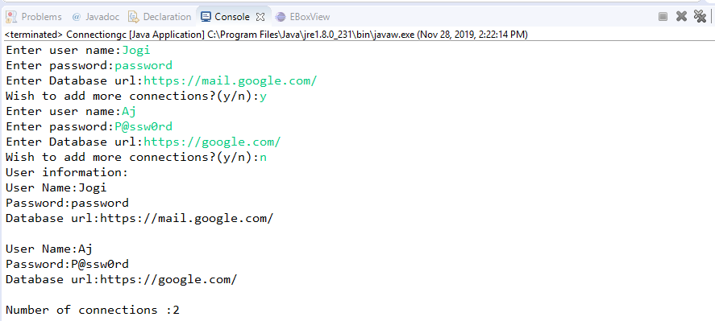

**Program:3**

**package** Practice3;

**import** java.io.*;

**import** java.util.*;

**import** java.util.Scanner;

**public** **class** Time1 {

**public** **static** **void** main(String[] args) {

Scanner input = **new** Scanner(System.***in***);

String time = input.nextLine();

**int** hour = Integer.*parseInt*(time.substring(0,2));

**int** minute = Integer.*parseInt*(time.substring(3,5));

**int** second = Integer.*parseInt*(time.substring(6,8));

**if** (hour >= 0 && hour <= 23 && minute >= 0 && minute <= 59 && second >= 0 && second <= 59) {

System.***out***.println();

System.***out***.println(String.*format*("%01d",hour) + ":" + String.*format*("%02d",minute) + ":" + String.*format*("%02d",second));

}

**else**

{

System.***out***.println("invalid");

}

}

}

**Output:**

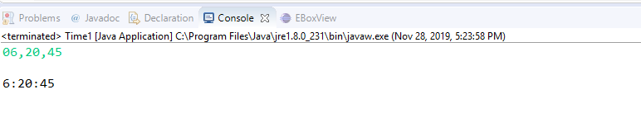

**Program:4**

**package** Practice3;

**import** java.util.ArrayList;

**import** java.util.List;

**class** Employee {

**private** String Name;

**private** String employee_code;

**private** **char** gender;

**private** String location;

**public** String getName() {

**return** Name;

}

**public** **void** setName(String name) {

Name = name;

}

**public** String getEmployee_code() {

**return** employee_code;

}

**public** **void** setEmployee_code(String employee_code) {

**this**.employee_code = employee_code;

}

**public** **char** getGender() {

**return** gender;

}

**public** **void** setGender(**char** gender) {

**this**.gender = gender;

}

**public** String getLocation() {

**return** location;

}

**public** **void** setLocation(String location) {

**this**.location = location;

}

**public** String autoIncrement(String employee_code){

String seq=employee_code.substring(1,5);

**char** firstChar=employee_code.charAt(0);

**int** seqval=Integer.*parseInt*(seq);

seqval++;

System.***out***.println("first char="+seq+"seqval=+seqval");

**if**(seqval<=10){

employee_code=(""+firstChar+"00"+seqval);

}

**else** **if**(seqval<=100){

employee_code=(""+firstChar+"0"+seqval);

}

**else** **if** (seqval<=1000){

employee_code=(""+firstChar+seqval);

}

**return** employee_code;

}

}

**public** **class** Employeeautogen{

**public** **static** **void** main(String[] args) {

List<Employee> elist=**new** ArrayList<Employee>();

**char** reply='y';

Employee e=**new** Employee();

e.setEmployee_code("W0009");

e.setEmployee_code(e.autoIncrement(e.getEmployee_code()));

System.***out***.println(e.getEmployee_code());

}

}

**Output:**

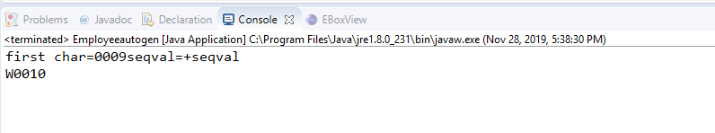

**Program:5**

**final** **class** Student1

{

**final** String name;

**final** **int** regNo;

**public** Student1(String name, **int** regNo)

{

**this**.name = name;

**this**.regNo = regNo;

}

**public** String getName()

{

**return** name;

}

**public** **int** getRegNo()

{

**return** regNo;

}

}

**public** **class** Test{

**public** **static** **void** main(String args[])

{

Student1 s = **new** Student1("Jogi",599);

System.***out***.println(s.getName());

System.***out***.println(s.getRegNo());

}

}

**Output:**

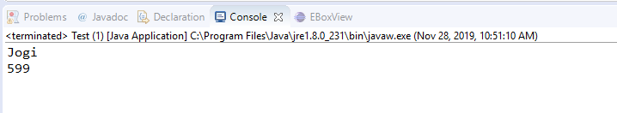

**Program:6**

import java.util.Scanner;  
public class Account {  
public static void main(String[] args) {  
long acct_no;  
String customer_name, trans_type, bank_name;  
double trans_amount, bal_amount, n_balance = 0, interest_amount = 0,rate,time;  
Scanner sc = new Scanner(System.in);  
System.out.print("Enter Account Number:");  
acct_no = sc.nextLong();  
System.out.print("Enter Customer Name:");  
customer_name = sc.next();  
System.out.print("Enter Bank Name:");  
bank_name = sc.next();  
System.out.print("Enter Transaction Type:");  
trans_type = sc.next();  
System.out.print("Enter Transaction Amount:");  
trans_amount = sc.nextDouble();  
System.out.print("Enter Balance:");  
bal_amount = sc.nextDouble();  
//System.out.print("Enter Interest Amount:");  
//interest_amount = sc.nextDouble();  
//System.out.print("Enter NewBalance:");  
//n_balance = sc.nextDouble();  
Bank b = new Bank(acct_no, customer_name, bank_name, trans_type, trans_amount, bal_amount,interest_amount, n_balance);  
b.transaction();  
}  
}  
class Bank {  
private long acct_no;  
private String customer_name, trans_type, bank_name;  
private double trans_amount, bal_amount, n_balance, interest_amount;  
public Bank(long acct_no, String customer_name,String bank_name, String trans_type, double trans_amount, double bal_amount, double interest_amount, double n_balance) {  
super();  
this.acct_no = acct_no;  
this.customer_name = customer_name;  
this.bank_name=bank_name;  
this.trans_type = trans_type;  
this.trans_amount = trans_amount;  
this.bal_amount = bal_amount;  
this.interest_amount=interest_amount;  
this.n_balance=n_balance;  
}  
public void transaction() {  
if (trans_type.equals("Withdrawal")) {  
if (trans_amount <= bal_amount) {    
n_balance = bal_amount - trans_amount;    
} else {  
System.out.println("invaid transaction");  
}  
}    
if(bank_name.equals("SBI"))  
{  
double rate = 3.75, time = 1;  
interest_amount =(bal_amount*rate*time)/100 + bal_amount;  
}  
else if(bank_name.equals("HDFC"))  
{  
double rate = 4.5, time = 1;  
interest_amount = (bal_amount*rate*time)/100 + bal_amount;  
}  
else  
{  
double rate = 5, time = 1;  
interest_amount = (bal_amount*rate*time)/100 + bal_amount;  
}  
if (trans_type.equals("Deposit")) {    
n_balance = bal_amount + trans_amount;    
}  
  
System.out.println("Customer Name: " + customer_name);  
System.out.println("Account Number: " + acct_no);  
System.out.println("Transaction type: " + trans_type);  
System.out.printf("Transaction amount: Rs.%.2f" , trans_amount);  
System.out.println();  
System.out.printf("Balance amount: Rs.%.2f" , bal_amount);  
System.out.println();  
System.out.printf("Interest amount: Rs.%.2f" , interest_amount);  
System.out.println();  
System.out.printf("New Balance: Rs.%.2f" , n_balance);  
}  
}

**Output:**

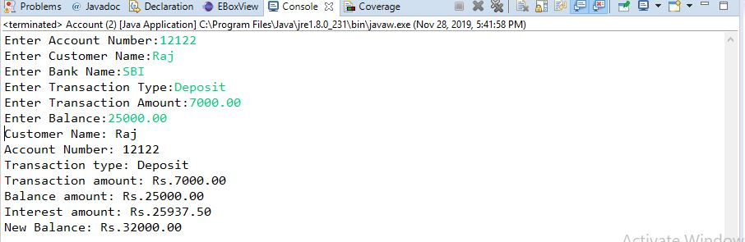

**Program:7**

**package** Practice3;

**import** java.util.ArrayList;

**import** java.util.Scanner;

**class** Student{}

**class** Trainer{ }

**class** Hcl{}

**public** **class** InstanceOFTutorial{

**static** String count(ArrayList mylist){

**int** a = 0,b = 0,c = 0;

**for**(**int** i = 0; i < mylist.size(); i++){

Object element=mylist.get(i);

**if**(element **instanceof** Student) a++;

**if**(element **instanceof** Trainer) b++;

**if**(element **instanceof** Hcl) c++;

}

String ret = Integer.*toString*(a)+" "+Integer.*toString*(b)+" "+ Integer.*toString*(c);

**return** ret;

}

**public** **static** **void** main(String []args){

ArrayList mylist = **new** ArrayList();

Scanner sc = **new** Scanner(System.***in***);

**int** t = sc.nextInt();

**for**(**int** i=0; i<t; i++){

String s=sc.next();

**if**(s.equals("Student"))mylist.add(**new** Student());

**if**(s.equals("Trainer"))mylist.add(**new** Trainer());

**if**(s.equals("Hcl"))mylist.add(**new** Hcl());

}

System.***out***.println(*count*(mylist));

}

}

**Output:**

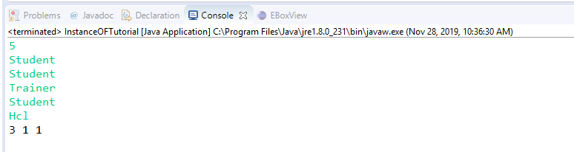

**Program:9**

**package** Practice3;

**import** java.util.Scanner;

**abstract** **class** Book{

String title;

**abstract** **void** setTitle(String s);

String getTitle(String title){

**return** title;

}

}

**class** MyBook **extends** Book{

@Override

**void** setTitle(String s) {

}

}

**class** Main{

**public** **static** **void** main(String []args){

Scanner sc=**new** Scanner(System.***in***);

String title=sc.nextLine();

MyBook new_novel=**new** MyBook();

new_novel.setTitle(title);

System.***out***.println("The title is: "+new_novel.getTitle(title));

sc.close();

}

}

**Output:**

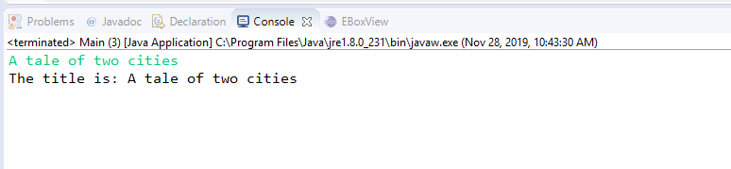

**Program:10**

**package** Practice3;

**import** java.util.*;

**import** java.io.*;

**class** BiCycle{

String define_me(){

**return** "a vehicle with pedals.";

}

}

**class** MotorCycle **extends** BiCycle{

String define_me1()

{

**return** "a cycle with an engine.";

}

MotorCycle(){

System.***out***.println("Hello I am a motorcycle, I am "+ define_me1());

String temp=define_me();

System.***out***.println("My ancestor is a cycle who is "+ temp );

}

}

**class** Solution{

**public** **static** **void** main(String []args){

MotorCycle M=**new** MotorCycle();

}

}

**Output:**

